

**MIPS REPORT**

**Name: Mazen Aly Darwish.**

**Reg: 20100432.**

**Submitted to: Dr. Marwa ElShennawy and Eng. Esraa Khattab.**

**Components used in the project:**

**1-ALU**

**2-ALU CONTROL**

**3-INSTRUCTION MEMORY**

**4-DATA MEMORY**

**5-CONTROL UNIT**

**6-2_1 32 BIT MUX**

**7-2_1 5 BIT MUX**

**8-PC+4 ADDER**

**9-32 BIT ADDER**

**10-REGISTER**

**11-PC COUNTER**

**12-SIGN EXTEND**

**13-SHIFT LEFT**

**1) ALU:**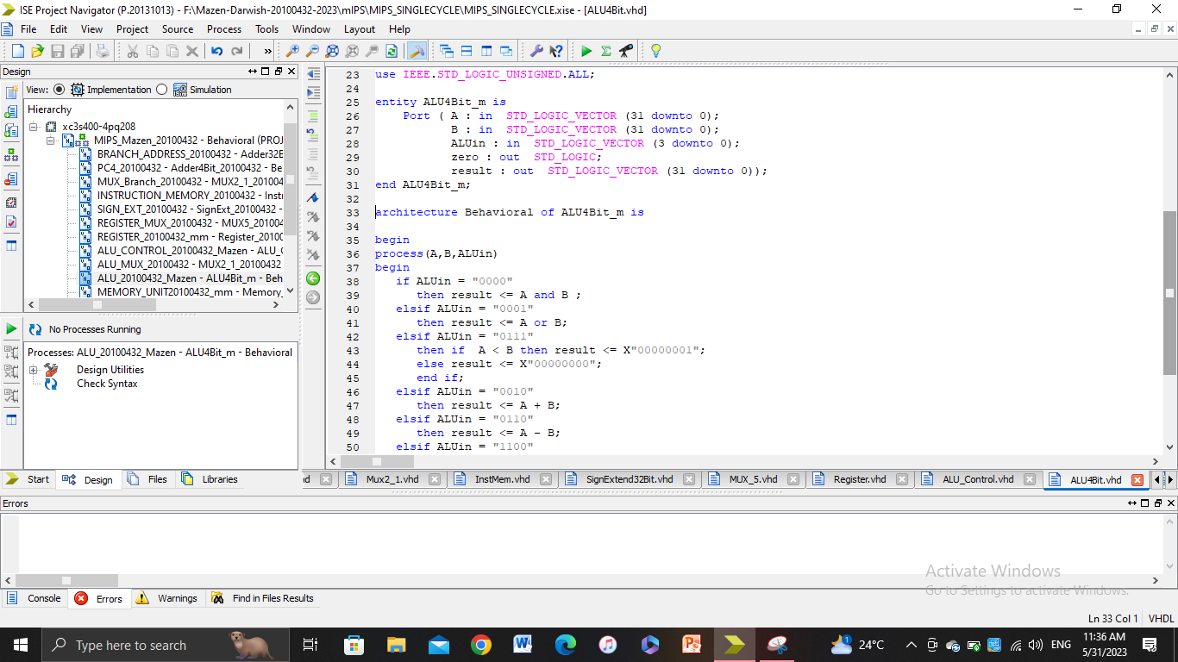

**2) ALU CONTROL:**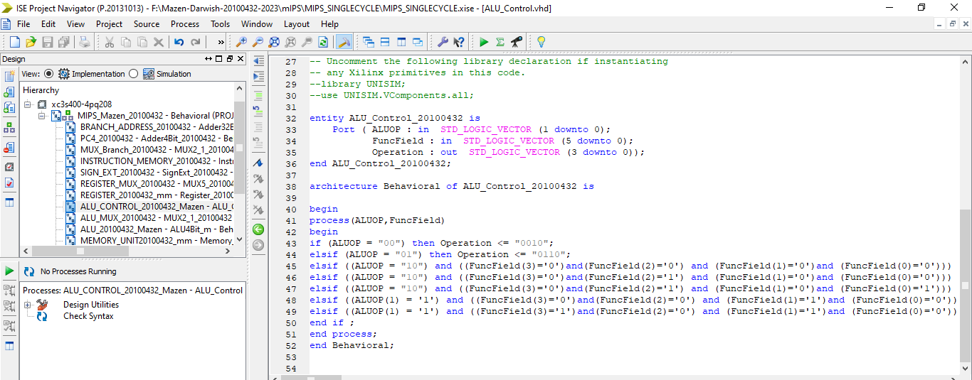

**3) INSTRUCTION MEMORY:**

**(Sorry for the bad screenshot)**

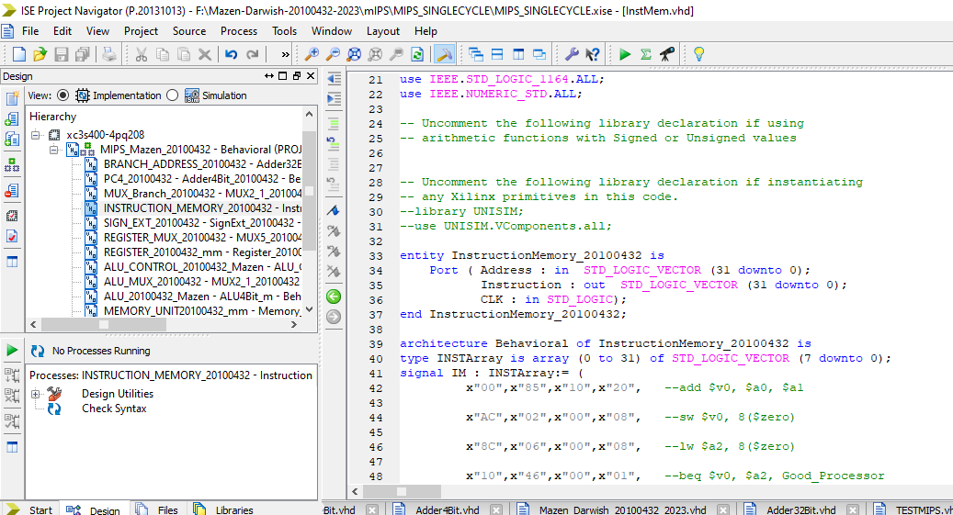

**4) DATA MEMORY:**

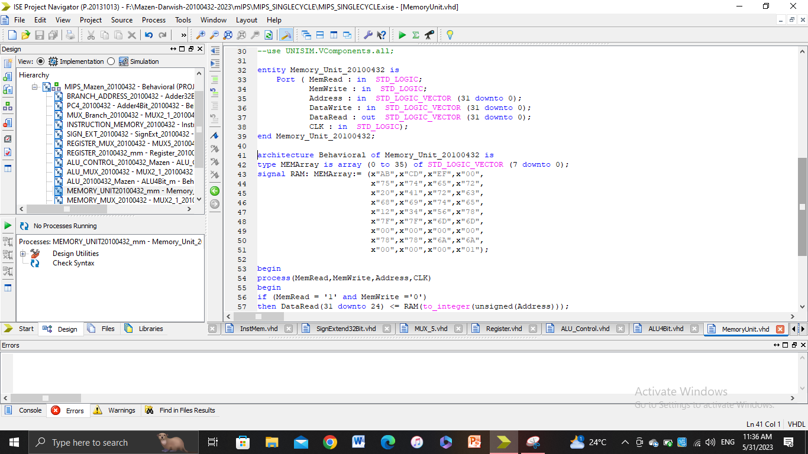

**5) CONTROL UNIT:**

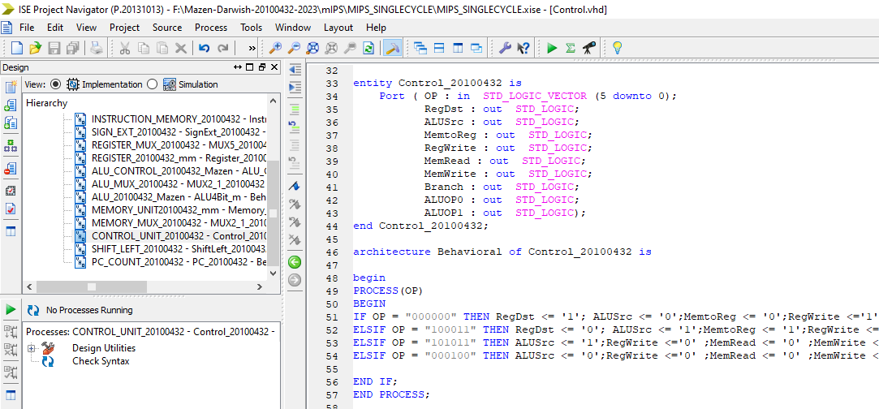

**7) 2_1 5 BIT MUX:**

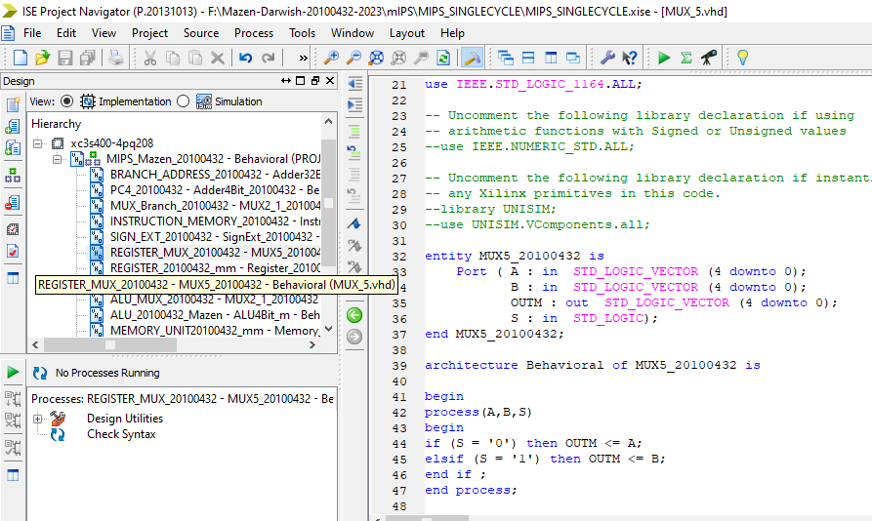

**9) 32 BIT ADDER:**

**10) Register:**

**11) PC COUNTER:**

**12) SIGN EXTEND:**

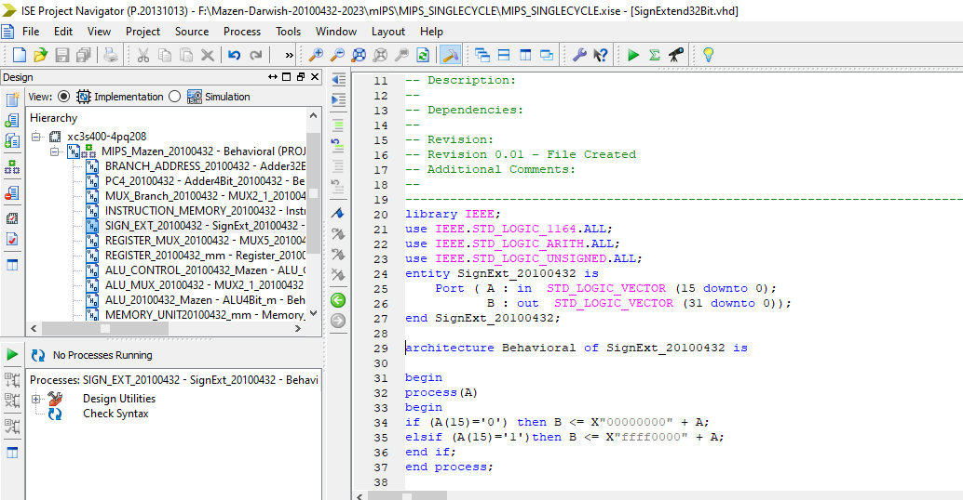

**13) SHIFT LEFT:**

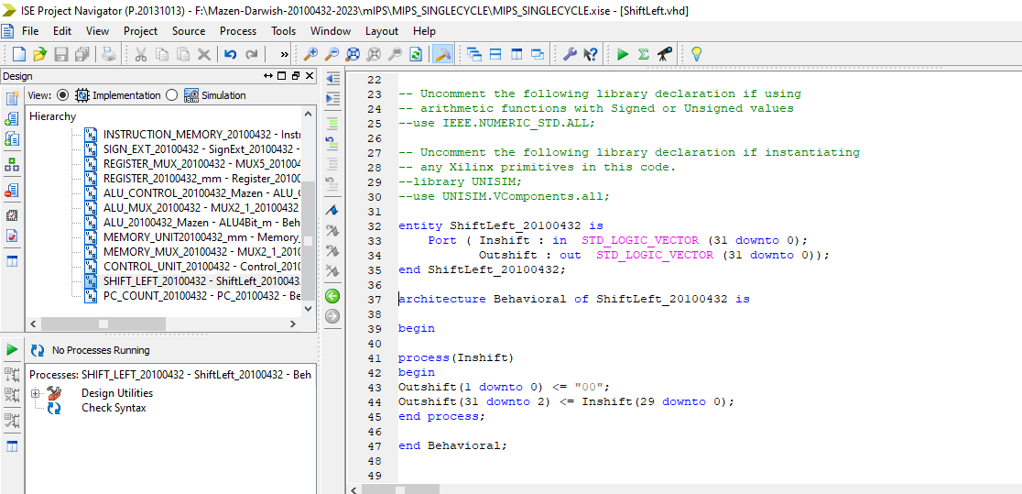

**SIMULATION:**

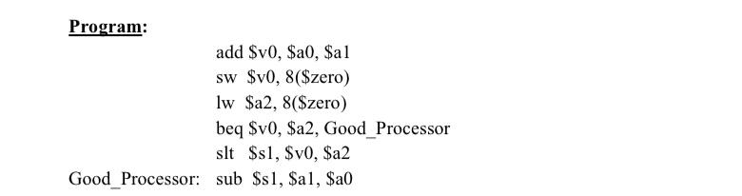

**1-add $v0, $a0, $a1**

**Adds the values stored in registers: $a0 and $a1 and stores them in $v0 which is located in register 2.**

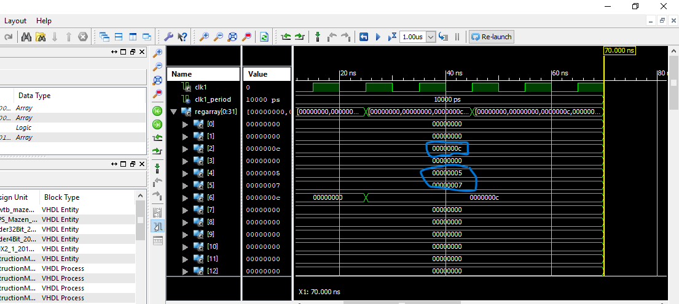

**2- sw $v0, 8($zero)**

**This instruction will store the value in $v0 in the offset 8 (from 8 to 11) because mips is bit addressable.**

**3- lw $a2, 8($zero)This instruction will load the value located in offset 8 (8 to 11) and store It in register $a2 which is register number 6.**

**4- beq $v0, $a2, Good_Processor**

**This instruction will subtract the values stored in registers $v0 and $a2 and if they are equal to 0 then it will proceed to the label.**

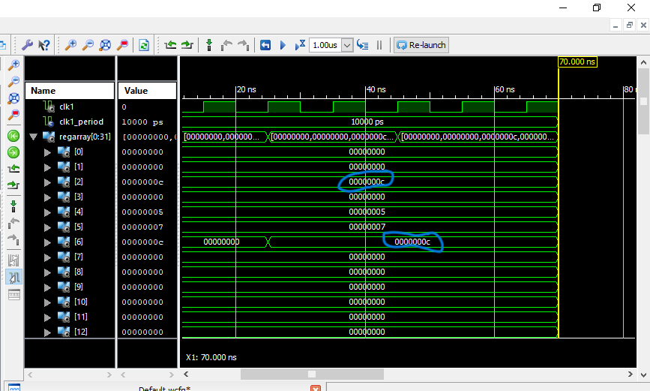

**5- slt $s1, $v0, $a2**

**This instruction will check if $v0 is less than $a2 and if this is wrong then it will set the value of $s1 to 1 and if the opposite is correct then it will set the value of $s1 to 0. A screen shot of a computer
**

**6- Good_Processor: sub $s1, $a1, $a0**

**This instruction subtracts the values stored in registers: $a1 and $a0 and stores them in $s1 which is located in register 17.**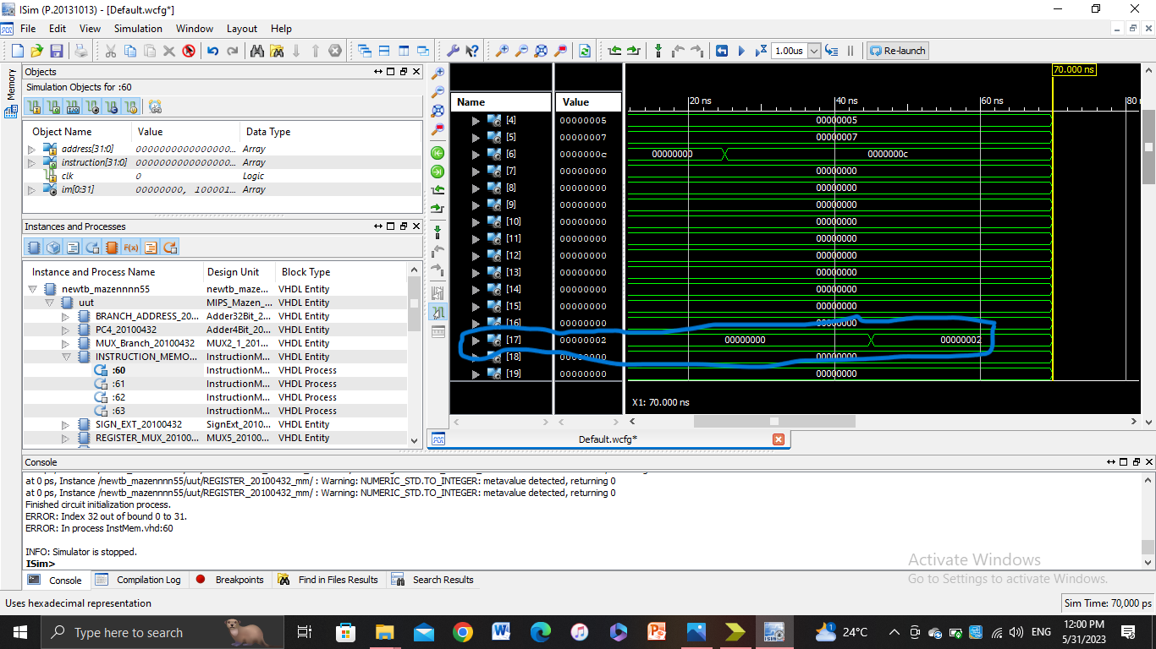

**PORT MAPPING:**

